Fighting Fires with Technology
How artificial intelligence, drones, robots, and satellites are revolutionising firefighting

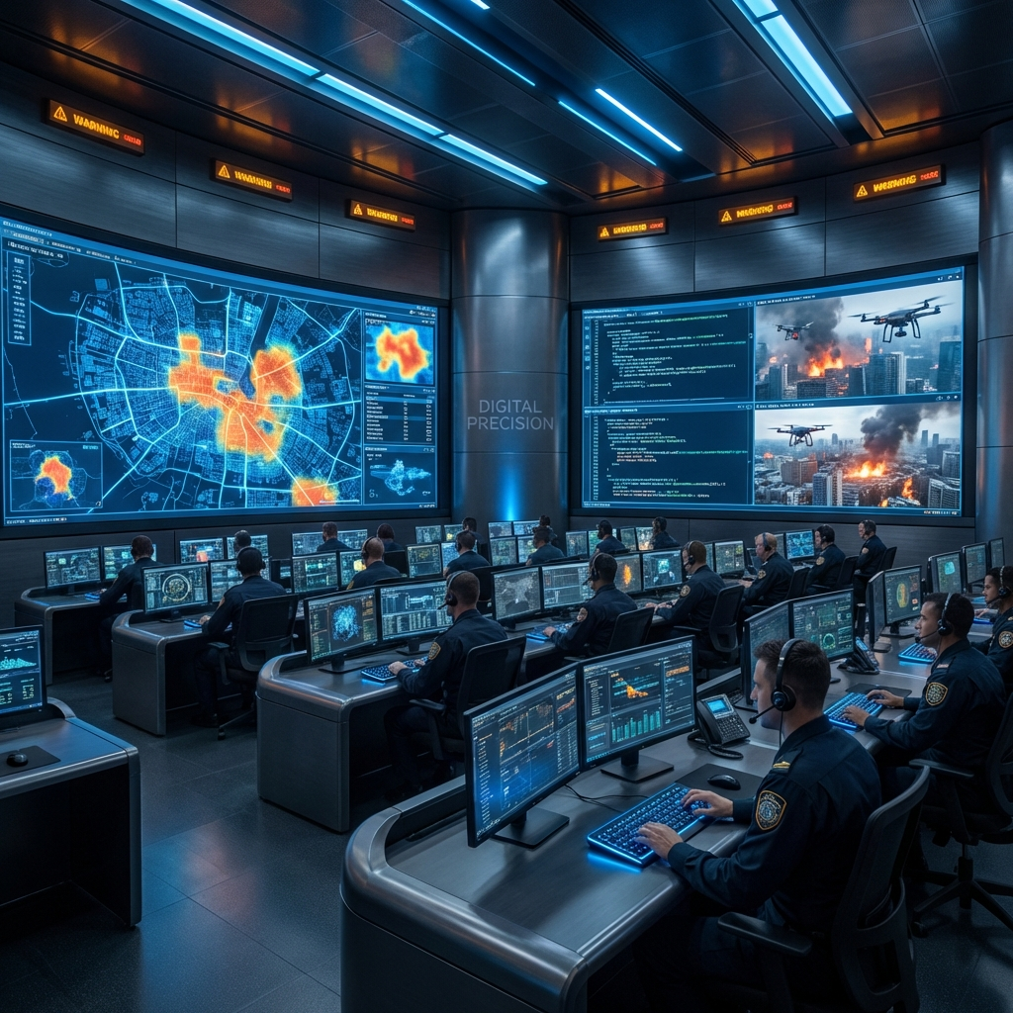

The Future of Firefighting is Here
Firefighters today are using amazing new tools that didn’t exist a few years ago. Because wildfires are getting bigger and more dangerous, new technology is helping firefighters stay safe and work faster.

Imagine a drone flying above thick smoke to find people who need help, or a robot rolling into a burning factory where humans can’t go. Even satellites in space can now spot tiny fires before anyone on the ground sees them. These tools are changing how we fight fires and helping save more lives than ever.

Eyes in the Sky: Firefighting Drones
Drones are no longer just flying cameras. They are tough machines built to survive heat, smoke, and dangerous environments.  Some special drones, like the FireDrone, can fly very close to flames without melting. They can:  - Fly into dangerous areas  - Find hotspots using special heat-sensing cameras  - Search for people using high-quality sensors  - Send live video and data to firefighters  Other drones can even blow away smoke to make safe paths for people. Tethered drones (connected by a cable) can carry heavy gear to the tops of tall buildings and stay in the air for a very long time because they don’t run out of battery. | 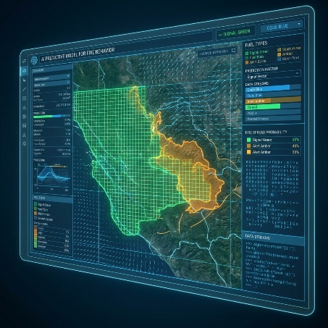

Types of Firefighting Drones
- Tethered Firefighting Drones - Ideal for high-rise buildings, they have a constant power source and can stay airborne for days.
- Search and Rescue Drones - Equipped with AI to detect human heat signatures even through thick concrete or timber debris.
- Prop-Wash Drones - Specialized rotors used to 'blow away' smoke and toxic gases from room exits.

Artificial Intelligence: The Predictive Edge
Artificial Intelligence (AI) helps firefighters predict where fires might start and how they might spread. AI studies things like:
- temperature
- wind
- humidity
- how dry plants are

Some AI systems, like DeepFire, can guess where a fire might move with very high accuracy. This means firefighters can prepare early—before a fire even begins. They can move equipment, warn people, and get ready faster than ever.

Space-Based Surveillance: The Global Eye
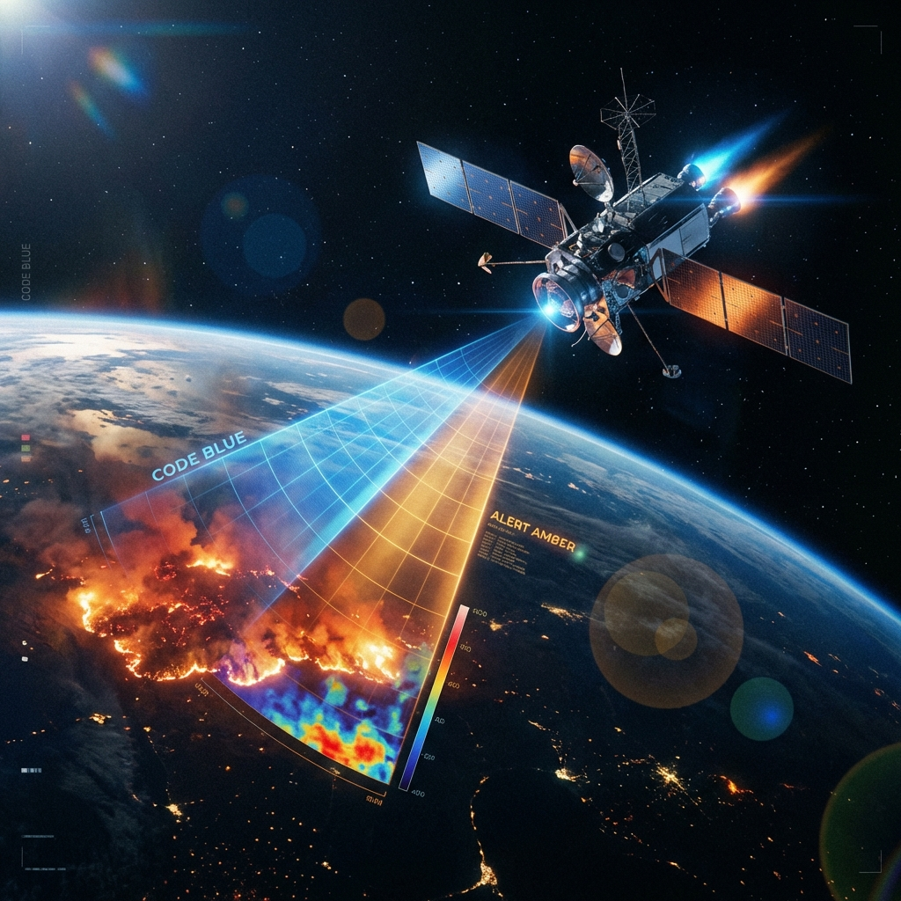

Satellites orbiting high above Earth can now spot very small fires—sometimes only the size of a classroom. Projects like FireSat use special heat cameras to watch forests and other fire-prone areas all around the world.

In places where fires are common, satellites can check the same area every few minutes. This helps firefighters find fires early, before they grow into huge, dangerous wildfires.

Robots in the Red Zone

Robots can go into places too risky for humans. Some robots can pull heavy hoses, drive over collapsed buildings, and survive extreme heat. Others, like humanoid robots, can climb stairs, open doors, and turn valves in smoky areas where humans would struggle.  These robots use lasers to map rooms even when thick smoke makes cameras useless. | 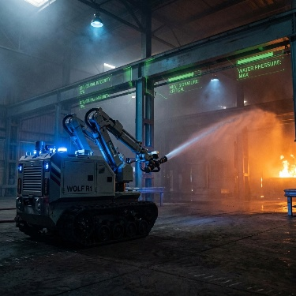

Connected Safety: The Internet of Things

Firefighters now use gear with tiny sensors built inside. These sensors can track:
- heart rate
- body temperature
- dangerous gases in the air
- the firefighter’s exact location inside a building

If something goes wrong—like a sudden heat spike or no movement—the system instantly sends an alert. This helps keep firefighters safe while they work in dangerous places.

Human-Tech Collaboration
All these tools don’t replace firefighters—they help them. Robots and drones take care of the dangerous, dirty, and dull jobs so humans can focus on rescuing people and making important decisions.

Technology is making fires easier to detect, firefighters safer, and communities better protected. The future of firefighting isn’t humans or machines—it’s humans and machines working as a team.
.

